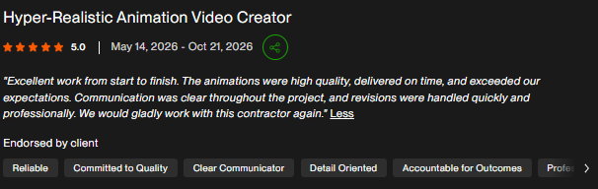
JOB DESCRIPTION:
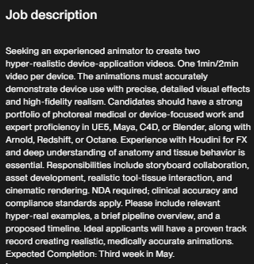
My Work:
I created 3 animations for 2 different products for a Medical company, Memsel https://www.memsel.com. I created Multiple shots, with blood spurting from the wound scenes, cross-sections, a soldier bandaged and injured, hospital shots, and a helicopter carrying the soldier for safety. Due to an NDA, I can’t provide more details.

Meddefender:
https://drive.google.com/file/d/1VZnWbqZb-5Cca6E1mbVtM18oC1dzIX61/view?usp=drive_link
https://drive.google.com/file/d/1UEWvf-_5SQdpgLgBx9CALJz-4O6bivT3/view?usp=drive_link
https://drive.google.com/file/d/1xgkFAGgy8gBu6y0AJ9_-KuEk1EXeZMZm/view?usp=drive_link
Blood spurting:
https://drive.google.com/file/d/1zgfJnynNPFlnFhnqSzJ0kNDuwLst5hvp/view?usp=drive_link

MedBeads:
https://drive.google.com/file/d/1Dt9bsyaotPfUi1yPR2zM3Ipqk8UTussK/view?usp=drive_link
https://drive.google.com/file/d/11AqiBxUPkbc6R5kCfrwugjY3vjFYVQ-x/view?usp=drive_link
https://drive.google.com/file/d/19FRf3i_eMPIzu06YIPZANWQrMB9otFzI/view?usp=drive_link
https://drive.google.com/file/d/1hkPwnNQwrgpOh5bWVVsxxF14qLGzVA_h/view?usp=drive_link
https://drive.google.com/file/d/1RUEFe_LUg1XhrYneHBo4VCgBykOwH2m7/view?usp=drive_link
—------------------------------------------------------------------------------------------------------------------
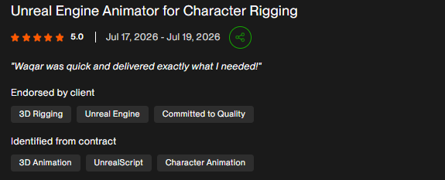
JOB DESCRIPTION:
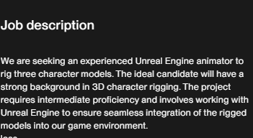
My Work:
This is a project where I created rigs for character models provided by the client and integrated them into Unreal Engine,

Idle animation:
https://drive.google.com/file/d/168iDrBAy60UhjiDojoHXIFF6JQJgBUWA/view?usp=drive%5Flink
Rig Point: https://drive.google.com/file/d/1cz316EXG3yEGSE%5FtwzU7V2oN%5FeCWAP1t/view?usp=drive%5Flink
Cop:
https://drive.google.com/file/d/1mN-wmaN%5FPNCSFfuEZb5qdst4d2GrEd%5Fx/view?usp=drive%5Flink
Female: https://drive.google.com/file/d/1Z7sMUsPWU185yPZeZm9bbpbTMcwz3BMz/view?usp=drive%5Flink
Male: https://drive.google.com/file/d/1qdNLD9kXmWi%5FAj%5FPzWPXYBl2%5FWfRq5Sk/view?usp=drive%5Flink
—-----------------------------------------------------------------------------------------------------------------
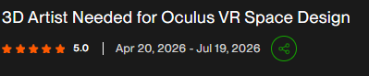
JOB DESCRIPTION:
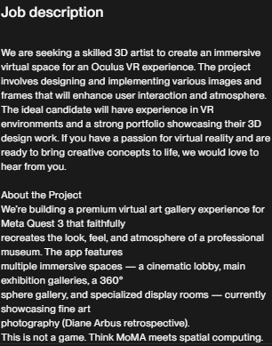
My Work:

This is a project I have recently completed where, from a provided reference, I created a photo gallery environment and models, then integrated it into VR and shared the APK for the client to test out for himself;

Reference:
https://drive.google.com/drive/folders/1pon0ttLCTupUoDDTfMwT4m-WFA17SOpH?usp=drive%5Flink
Models:
https://drive.google.com/drive/folders/1cgCpYwzGbg12yDI2aLe%5FJIlc%5F36%5FlMCJ?usp=drive%5Flink
Animation:
https://drive.google.com/file/d/1aHpX4WiayHfuDBE2ZR0mVr8CXS0EVzPq/view?usp=drive%5Flink
APK:
https://drive.google.com/file/d/1MY8qE-NZ2wEFn097vjh5WDa9-qeip8Gn/view?usp=drive%5Flink
—-----------------------------------------------------------------------------------------------------------------------
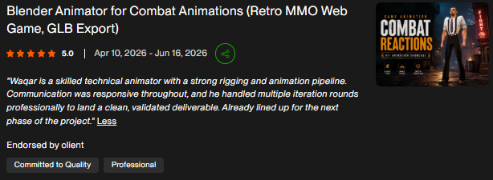
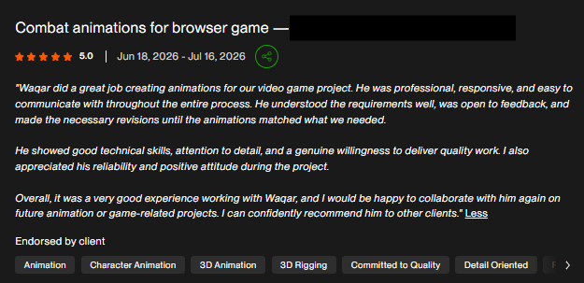
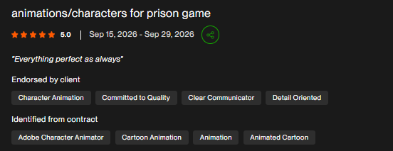
JOB DESCRIPTION:
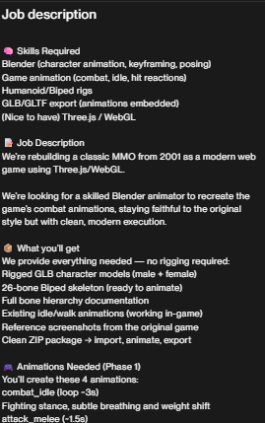
My work:
This is a project I have done where a client provided a reference for his game, and I worked on the rigging and animation of a combat reaction for a retro style game character;

Reference:
https://drive.google.com/drive/folders/1Y-4r-p2-dMfOTuy9ORqKdMXPU%5FIEdW-r?usp=drive%5Flink

Animation:

Combat reaction:
https://drive.google.com/file/d/1gEW%5FOUGYGn6%5F43V8pznXRNxldSyGrf0w/view?usp=drive%5Flink
Hit reaction:
https://drive.google.com/file/d/1-LVEmmgTdHZQkjD7mN3nvpzenBgbIpY7/view?usp=drive%5Flink
Blade Attack:
https://drive.google.com/file/d/1kcl9b96u7cHsM3WCuGzjo7LorJ8QwfHO/view?usp=drive%5Flink
Pistol attack:
https://drive.google.com/file/d/15G83WjkraHrGE561gEdv-dMmjsd4CFN9/view?usp=drive%5Flink
Run cycle:
https://drive.google.com/file/d/18XAYSOCbSBW59RFDRtksfRdAKZ6CKztZ/view?usp=drive%5Flink

Rigging work:
https://drive.google.com/file/d/1Te5qnBIYF9GL7bXgcZGv5%5FNn4tfMxiha/view?usp=drive%5Flink
—------------------------------------------------------------------------------------------------------------------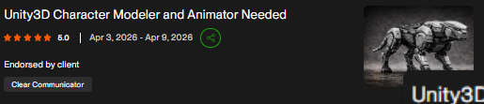
JOB DESCRIPTION:
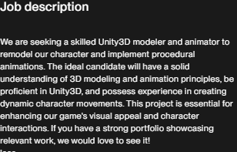
My work:
This is a project I recently completed. The client provided me with the model that he generated using Meshy AI and Maximo. I had to clean it up, ensuring proper topology, UVs, and accurate rigging, all integrated into Unity for procedural animation.

Models;
https://drive.google.com/drive/folders/10s0eq011dGobwmSYyMKwfpgCMytQl68S?usp=drive%5Flink
Final animation;
https://drive.google.com/file/d/1ITy-IAw43DtaP3xKx6kZr2vAHvnErB9m/view?usp=drive%5Flink

—------------------------------------------------------------------------------------------------------
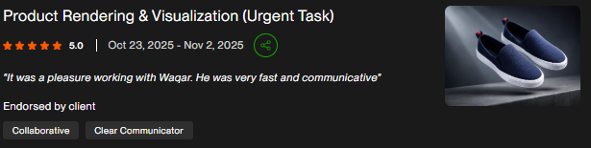

JOB DESCRIPTION:
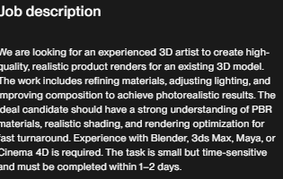
My Work:
I refined an existing 3D product model by enhancing PBR materials, improving surface realism, optimizing lighting setups, and adjusting camera composition to achieve photorealistic results
https://drive.google.com/drive/folders/1fABeOlKfmJDYVs9dGvlOC6aHhN1ezoyu?usp=drive_link
—--------------------------------------------------------------------------------------------------------------

